**Assignment 3**

The Netflix Prize data has over 100 million records of ratings. There are about 17k movies. Determine the correlations of each pair among all the movies. Report all the pairs with correlation >0.90.

To calculate the correlation, you need to define a vector for each movie. The vector can be all the ratings for that movie. Note some users have not rated that movie. You may treat the absence of ratings as a special number such as 0 or -1.

1. Print all the columns:

1. Create Two subset with two movies and ratings and fill one column with Zero.

1. Check the unique number of the movies

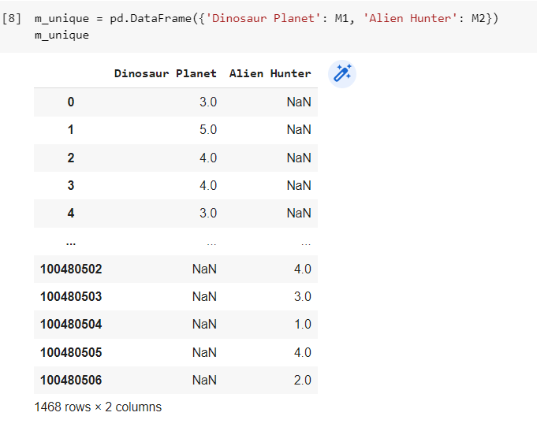

1. Check the missing values and fill it with zeros.

1. Check the correlation between the selected two movies.

1. Check the correlation between all the movies.

